**How to set up Delivery pipeline in Jenkins:**

* Chain required jobs in sequence.
* Install delivery pipeline plugin
* Add Delivery pipeline view, we can add it by clicking on + icon next to Test view as shown below:

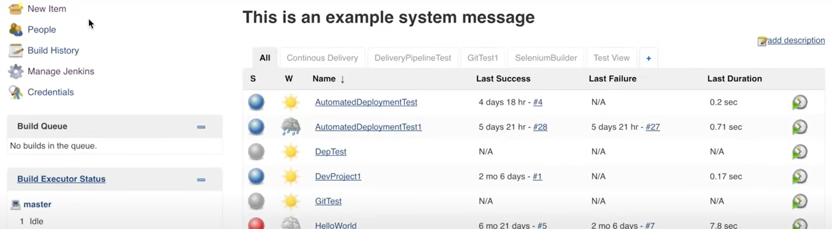

Then give the view name and select the type of view as below

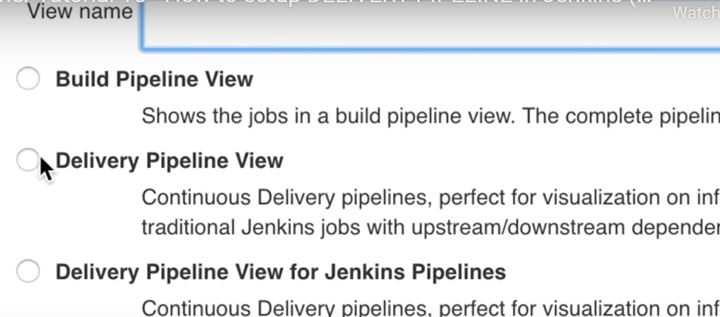

**How to set up build pipeline in Jenkins:**

* Chain required jobs in sequence .
* Install Build pipeline plugin
* Add Build pipeline view and configure the view.

After doing the configuration the build pipeline view will look like this

